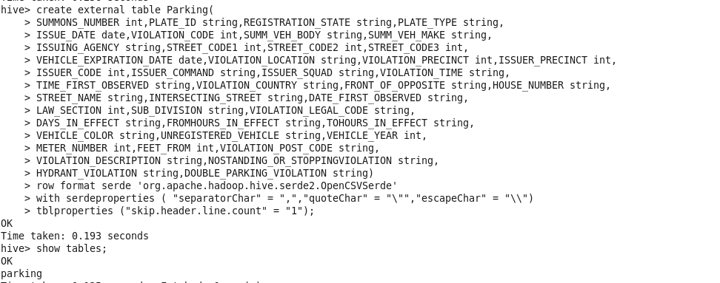



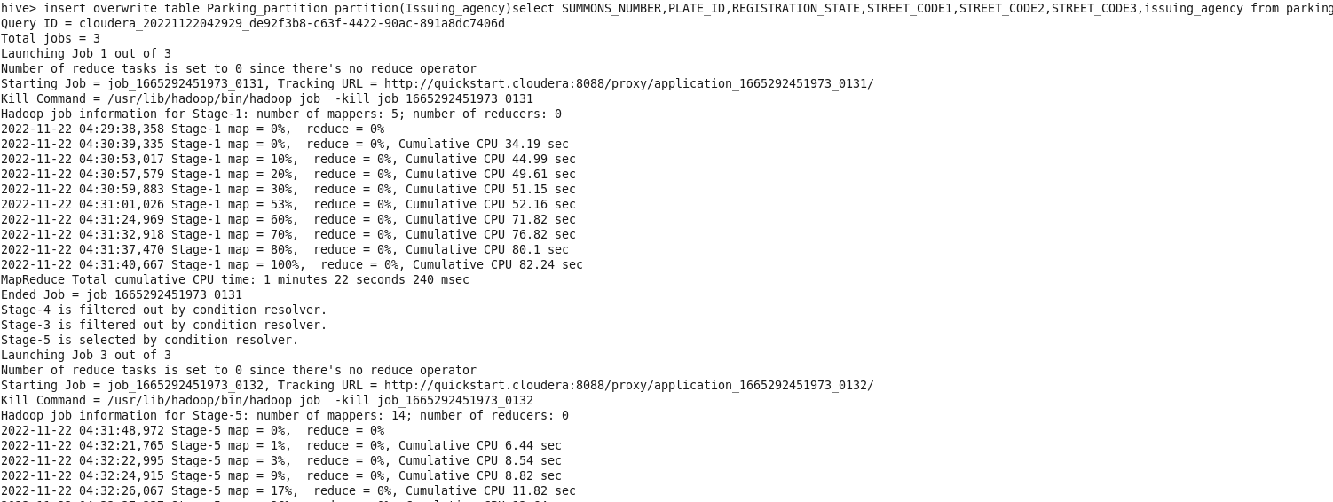

1. Find the total number of tickets for the year.

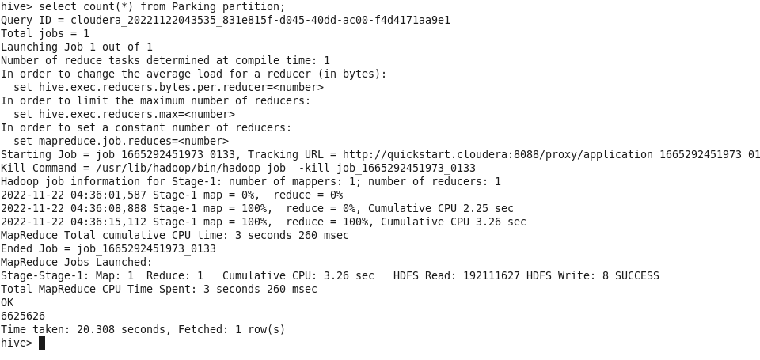

1. Find out how many unique states the cars which got parking tickets came from.

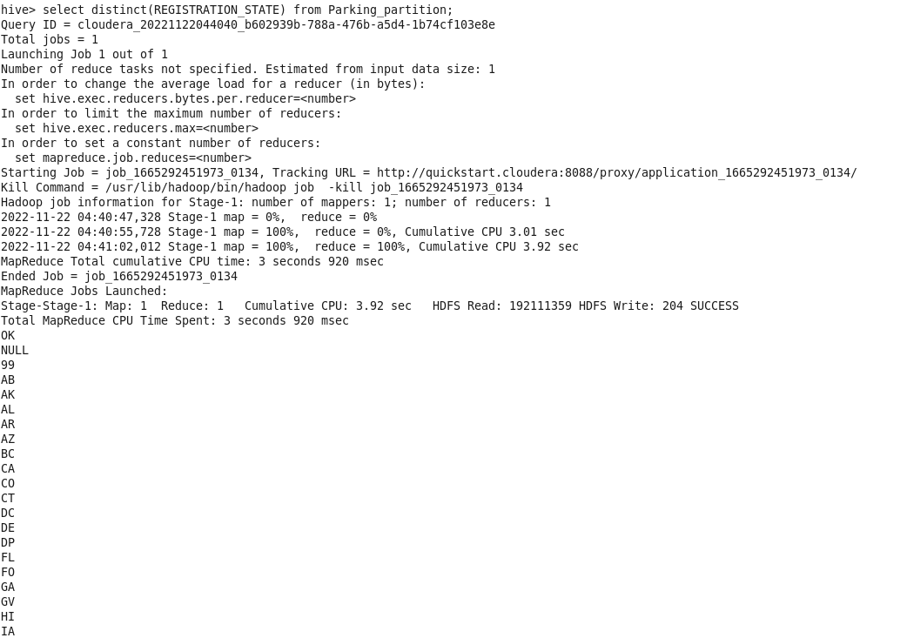

1. Some parking tickets don’t have addresses on them, which is cause for concern. Find out how many such tickets there are(i.e. tickets where either "Street Code 1" or "Street Code 2" or "Street Code 3" is empty )

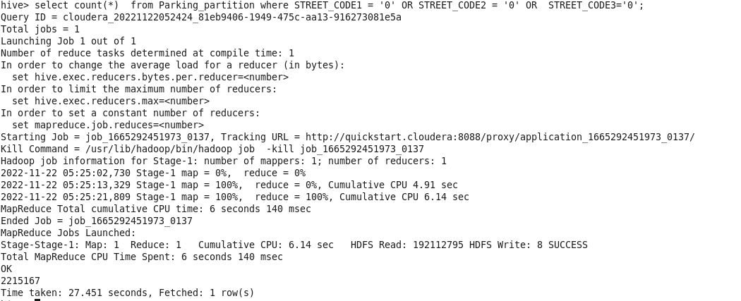

1. How often does each violation code occur? (frequency of violation codes - find the top 5)

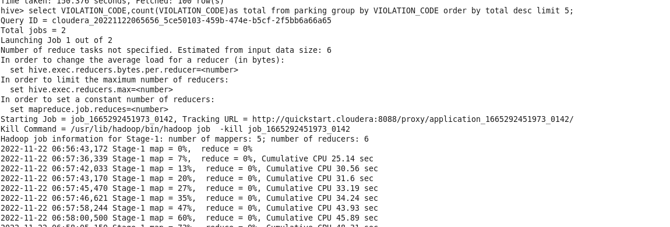

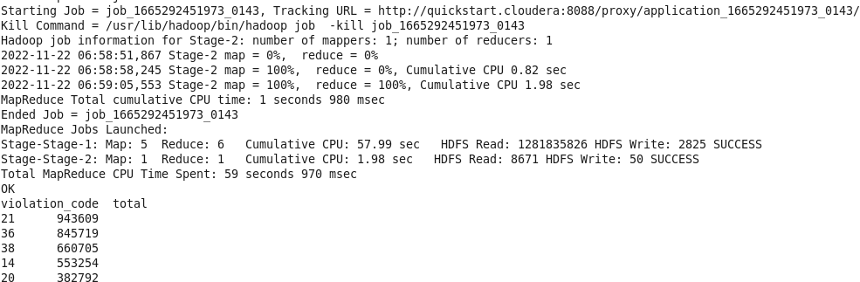

1. How often does each vehicle body type get a parking ticket? (find the top 5 for both)

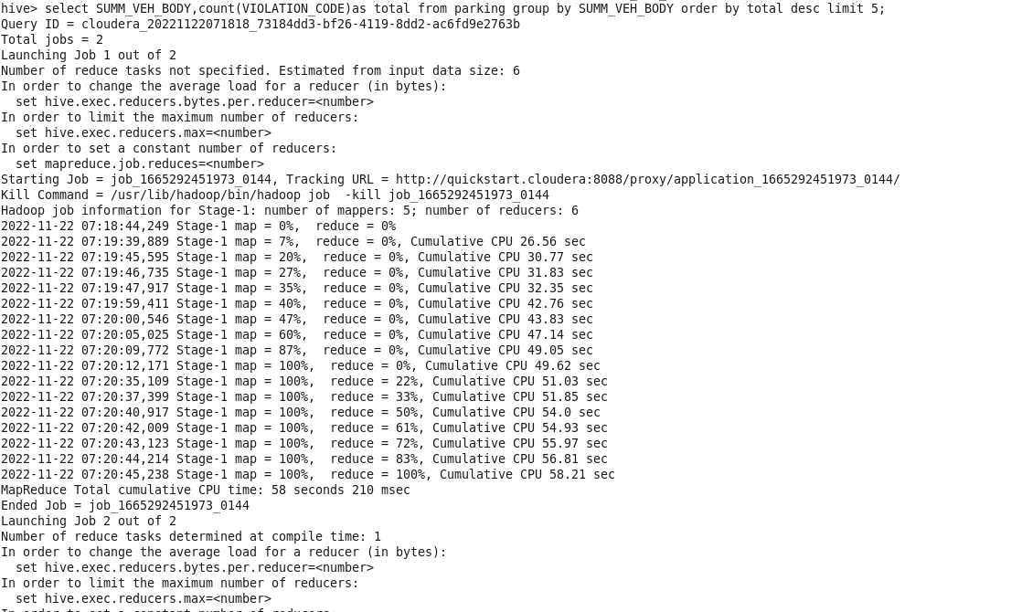

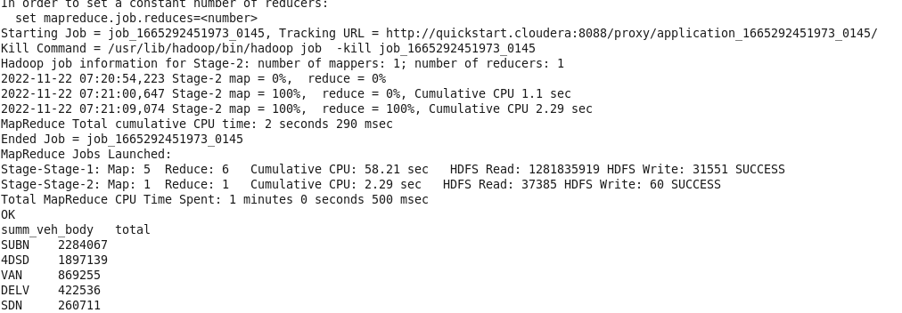

How about the vehicle make?

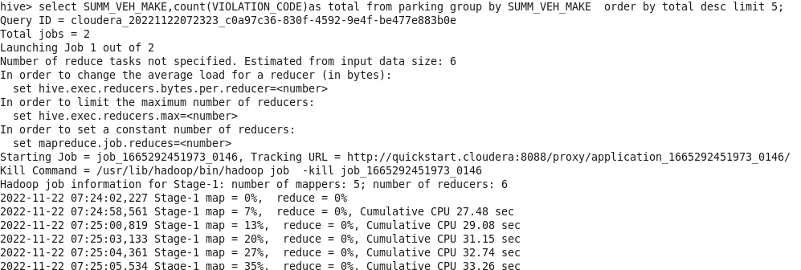

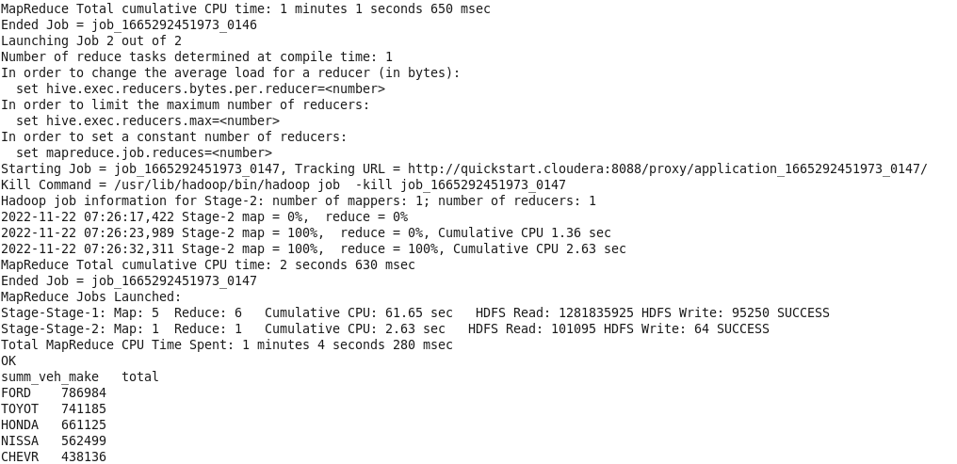

3.) A precinct is a police station that has a certain zone of the city under its command. Find the (5 highest) frequencies of:

a.) Violating Precincts (this is the precinct of the zone where the violation occurred)

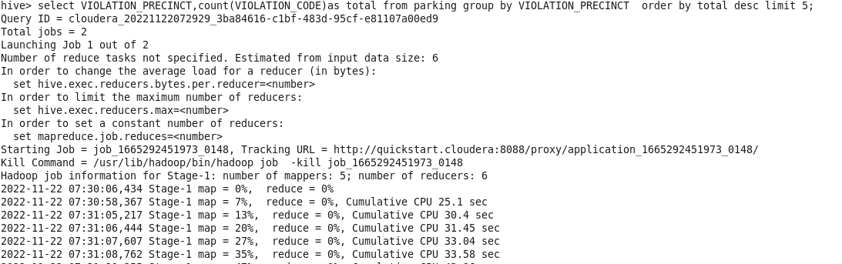

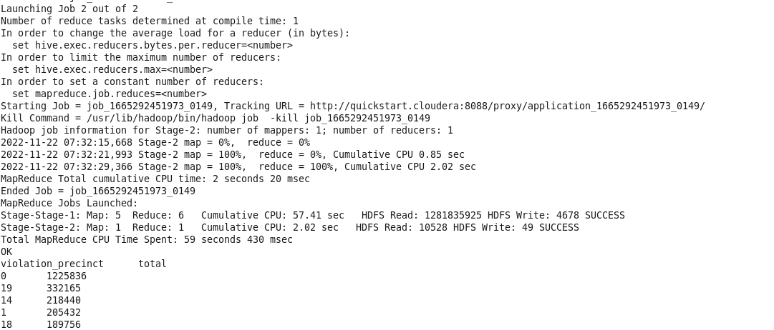

b.) Issuer Precincts (this is the precinct that issued the ticket)

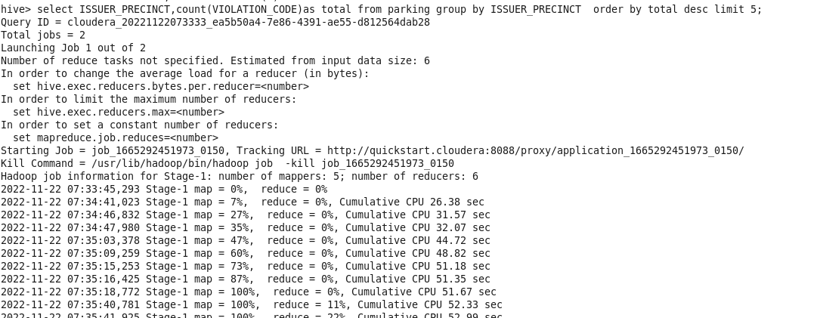

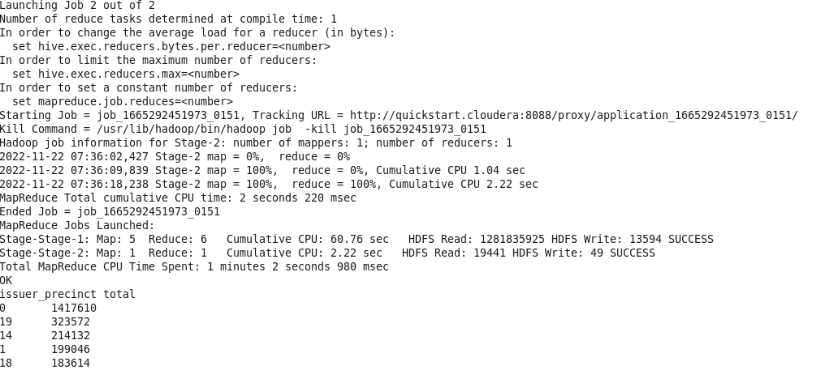

4)Find the violation code frequency across 3 precincts which have issued the most number of tickets - do these precinct zones have an exceptionally high frequency of certain violation codes?

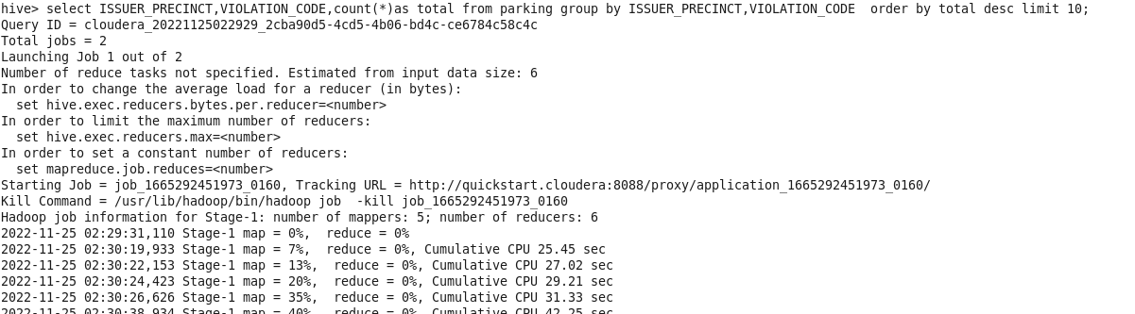

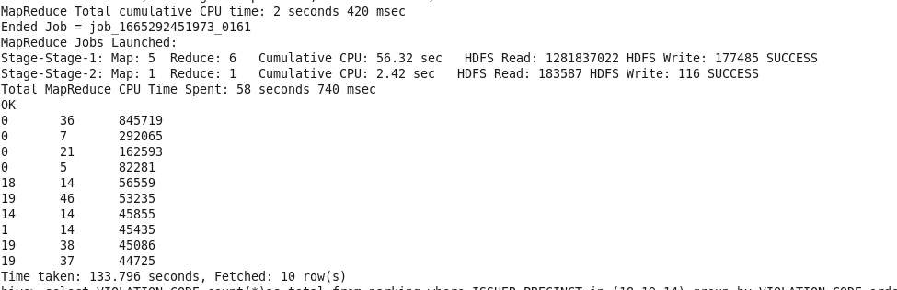

Since we are not considering 0 , we are executing below query to get top 3 and frequency

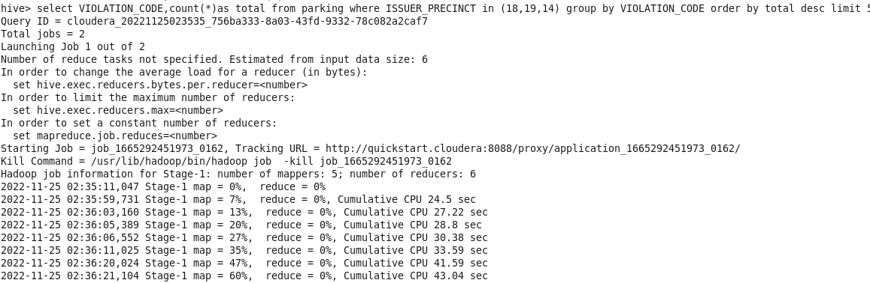

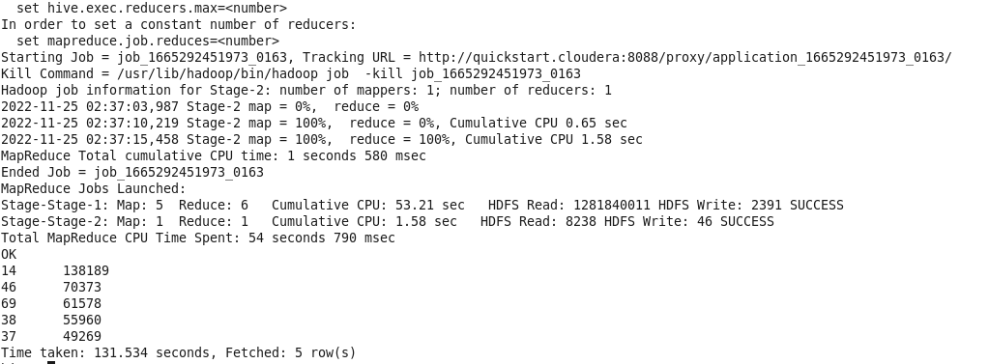

5)Find out the properties of parking violations across different times of the day:

The Violation Time field is specified in a strange format. Find a way to make this into a time attribute that you can use to divide into groups.

SELECT Summons_Number, Violation_Code , Violation_Time, Issuer_Precinct, case when substring(Violation_Time,1,2) in ('00','01','02','03','12') and upper(substring(Violation_Time,-1))='A' then 1 when substring(Violation_Time,1,2) in ('04','05','06','07') and upper(substring(Violation_Time,-1))='A' then 2 when substring(Violation_Time,1,2) in ('08','09','10','11') and upper(substring(Violation_Time,-1))='A' then 3 when substring(Violation_Time,1,2) in ('12','00','01','02','03') and upper(substring(Violation_Time,-1))='P' then 4 when substring(Violation_Time,1,2) in ('04','05','06','07') and upper(substring(Violation_Time,-1))='P' then 5 when substring(Violation_Time,1,2) in ('08','09','10','11') and upper(substring(Violation_Time,-1))='P' then 6 else null end as Violation_Time_bin from parking where Violation_Time is not null or (length(Violation_Time)=5 and upper(substring(Violation_Time,-1)) in ('A','P') and substring(Violation_Time,1,2) in ('00','01','02','03','04','05','06','07', '08','09','10','11','12'));

